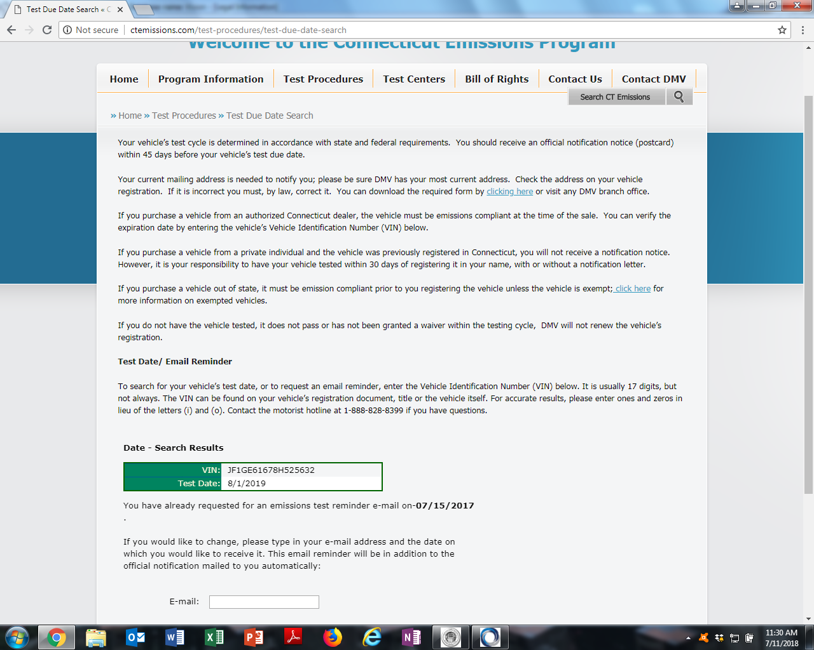
How to search emission test date
Go online and using the link below
http://ctemissions.com/test-procedures/test-due-date-search
Enter your vehicles vehicle identification number (VIN) in the box
The date of the test will appear in a green box below your VIN number ( the box color could be different in situation where the test is late)

