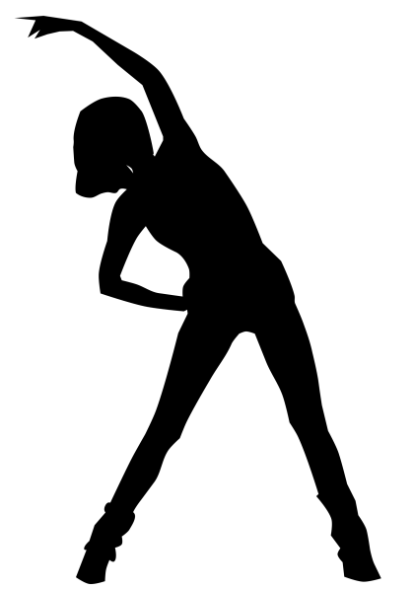

Columbia Parks & **Recreation**

860-228-8513

[recreation@columbiact.org](mailto:recreation@columbiact.org)

http://columbia.recdesk.com

**MON. WED. & FRI**

**4:30 PM – 5:30 PM**

**YEOMANS HALL**

**A FUSION OF ALL DISCIPLINES: CARDIO, MUSCLE, CORE AND BALANCE TO ROUND OUT A COMPLETE WORKOUT.**

Carol is a veteran group fitness instructor with a background in aerobics, step, core & muscle conditioning, Pilates, interval conditioning, Senior Fitness, Tabata Bootcamp, Bigger Losers Live, and HIIT (High Intensity Interval Training).

**$6 WALK-IN**

**$50 PREPAID**

**(10 CLASS PUNCHCARD)**

Bring….

* Water bottle
* Matt
* Exercise band (if you want)
* A friend!

FUSION

FIT